North Sea Advisory Council
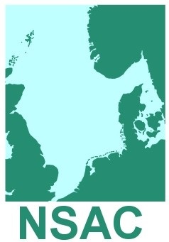
Monitoring, Control and Enforcement Focus Group
Danish Fishermen PO
H.C. Andersens Boulevard 37 1
1553 København V.
Denmark
3rd November 2016, 13:30 - 17:00

Draft (3)
AGENDA

- Welcome, apologies and appointment of Chairman
- Approval of Agenda
- Report of Last Meeting
Paper 3.1 Report of Meeting (For Approval)
- Report from Scheveningen Group control experts meeting 5th October
- Focus Group Terms of Reference
Paper 5.1 MCE Terms of Reference (For Discussion)

- Development of Advice
Paper 6.1 Monitoring and Control under the Landing Obligation
(For Discussion)

- Next steps and time scale
- Any other business

